# Apply filters to SQL queries

## Project description

[Describe what you accomplish through SQL.]

## Retrieve after hours failed login attempts

In order to retrieve the failed login attempts after the usual business hours (i.e 18:00:00), I have used filter clauses such as WHERE & AND. The ‘*’ symbol in the query is used to print all the columns of the given table log_in_attempts. The condition login_time > ‘18:00’ will only return the rows which have the login time of after 18:00. The success column in the table is of type boolean. In SQL boolean values are stored as 0 (FALSE) and 1 (TRUE). Hence, I have used the ‘=’ operator to get the records with success equals to 0 (False). Both these conditions are used with the ‘AND’ operator which will only return the rows with failed login attempts after ‘18:00’.

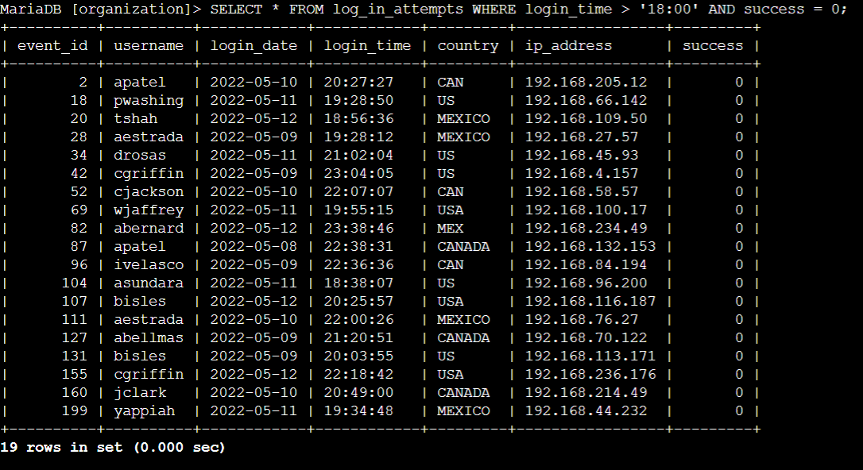

## Retrieve login attempts on specific dates

To view login attempts for specific dates, I used the ‘OR’ operator which will allow me to see rows satisfying login_date = ‘2022-05-09’ as well as login_date = ‘2022-05-08’ conditions for login date.

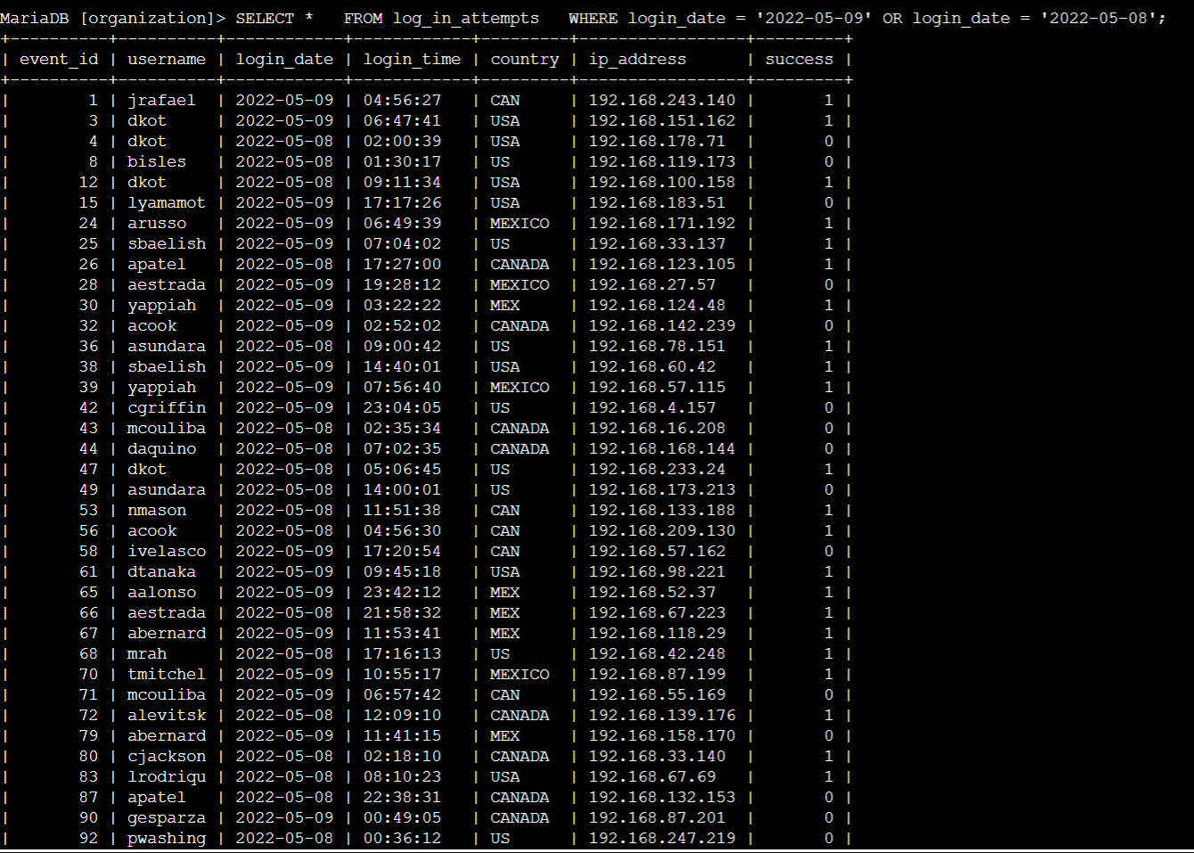

## Retrieve login attempts outside of Mexico

Here, I wanted the login attempts that were made outside of Mexico. In order to get these records, I used the ‘NOT’ condition which is used to select all the rows except the ones matching this condition. In the database, Mexico is represented as ‘MEXICO’ and ‘MEX’. To remove it successfully, ‘LIKE’ operator has been used with the ‘WHERE’ clause.

WHERE NOT country LIKE ‘MEX%’ here ‘%’ is used after MEX. This means that all the strings with starting characters ‘MEX’ will be excluded.

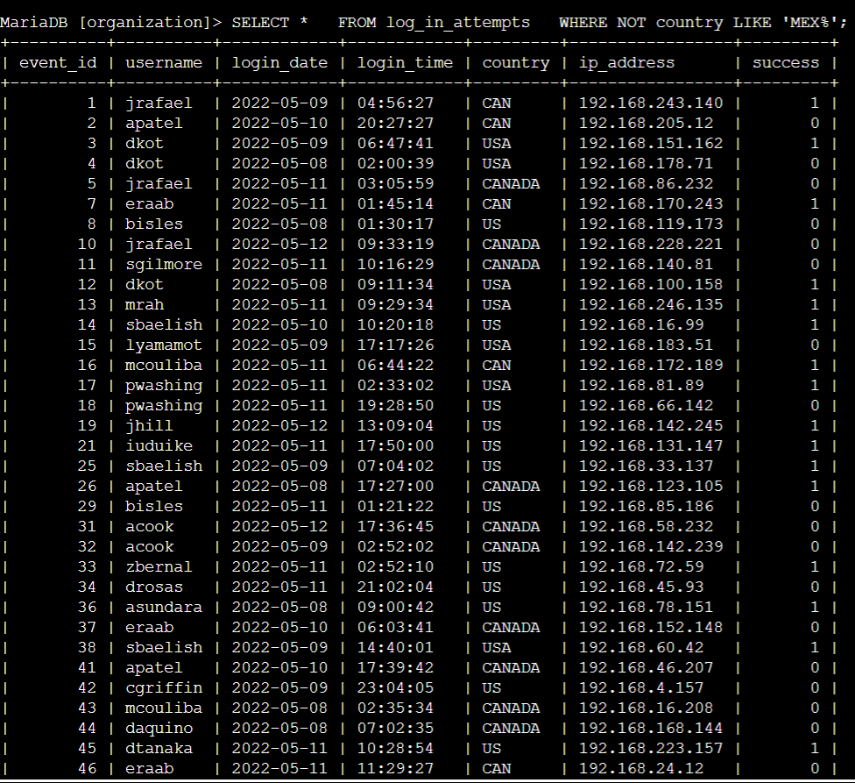

## Retrieve employees in Marketing

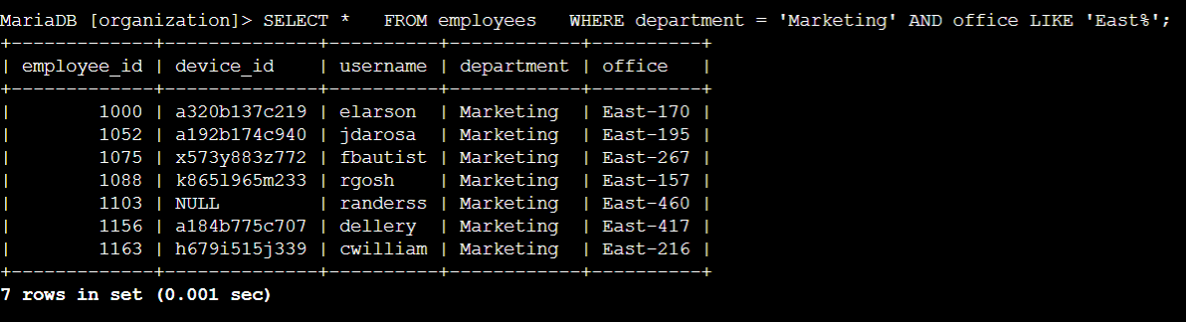

## Retrieve employees in Finance or Sales

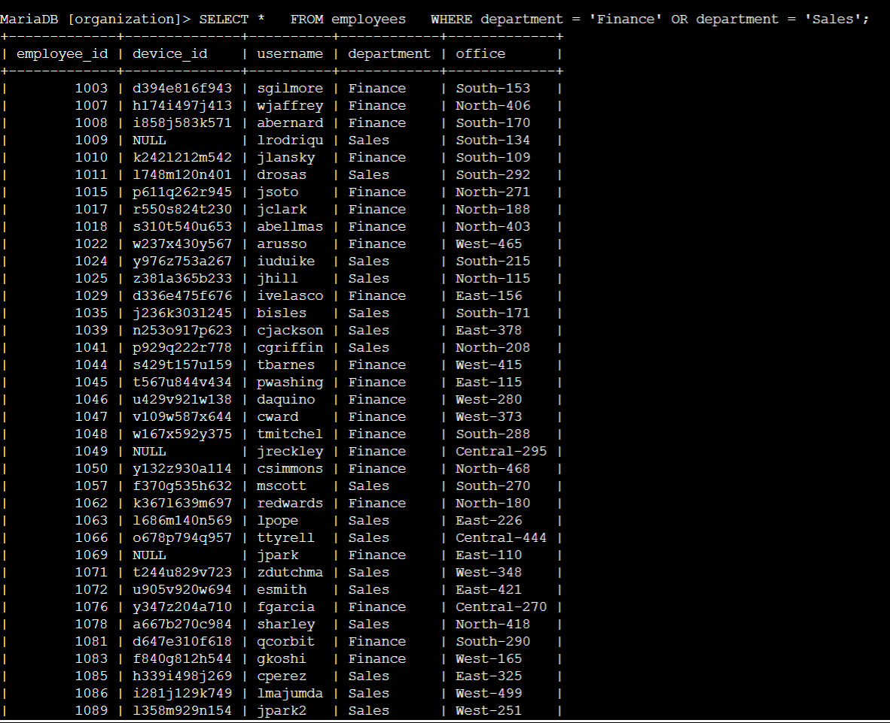

## Retrieve all employees not in IT

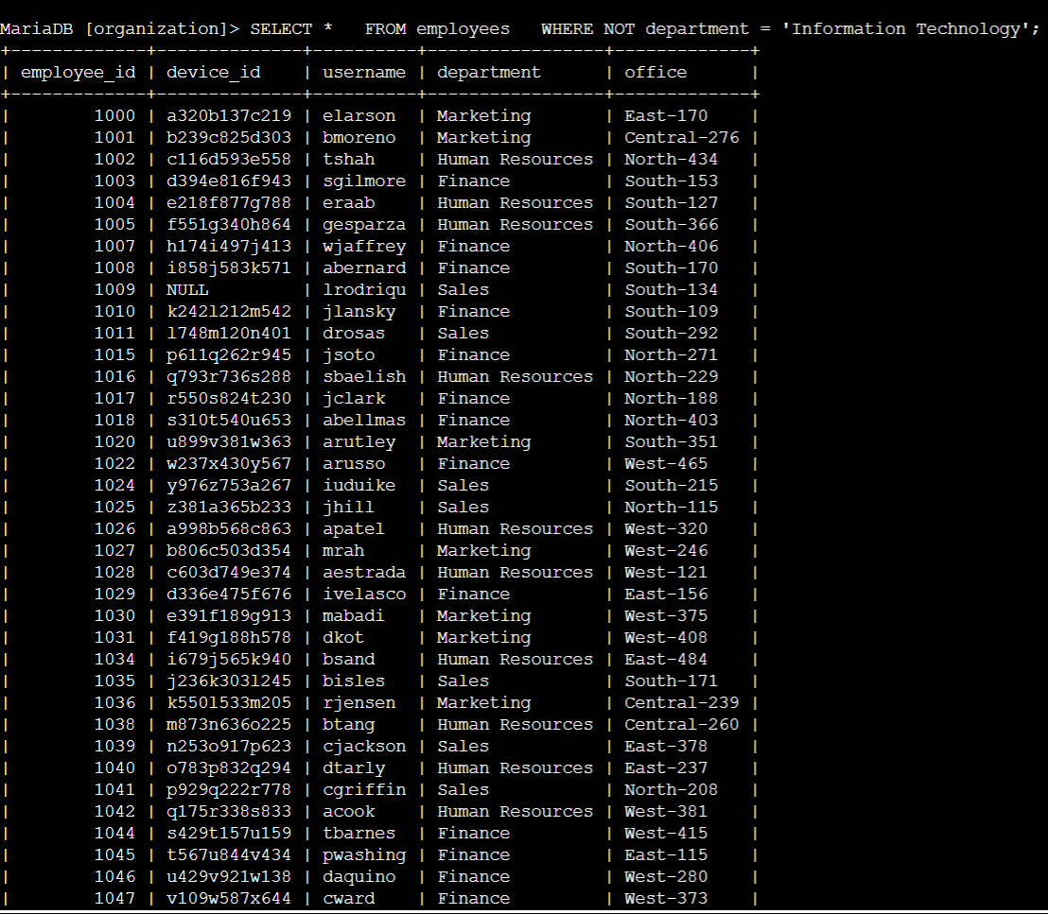

## Summary

I applied filters to SQL queries to get specific information on login attempts and employee

machines. I used two different tables, log_in_attempts and employees. I used the AND,

OR, and NOT operators to filter for the specific information needed for each task. I also used

LIKE and the percentage sign (%) wildcard to filter for patterns.